Astra track

**VARIOUS PART NUMBERS**

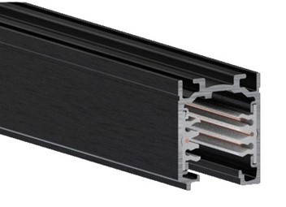



**Accessories**

End Cap: 9004/W Join: 9003/W

Live End: 9001/ W Suspension Kit: 9000-KIT4-1,5



**Production Information**

**–**

**Physical**

Length – 37.8mm

Width – 31.4mm

Finish – White

IP Rating – IP20

**–**

**Electrical**

Control – DALI2

